Please see the code repository URL for FrontEnd(Angular) and BackEnd(DotNet).

BackEnd

https://github.com/donjosdon1/DotNet1

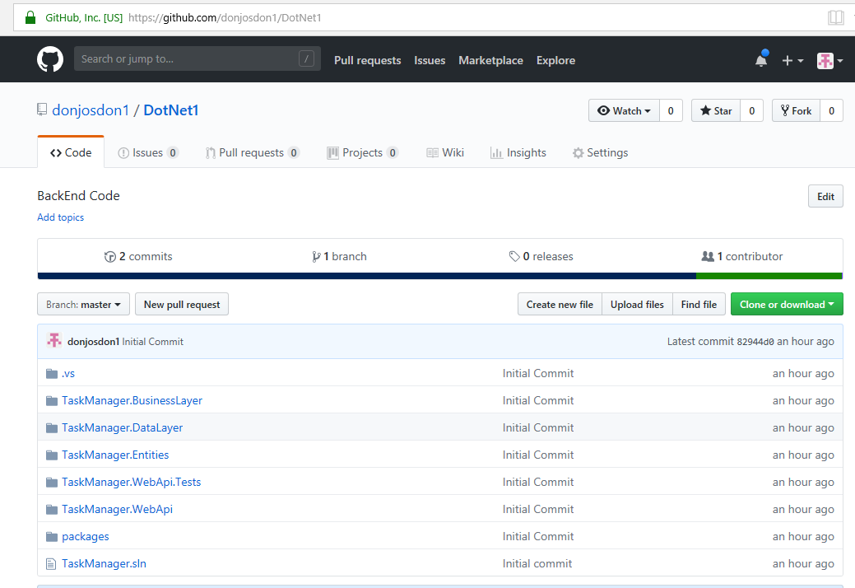

FrontEnd

<https://github.com/donjosdon1/ANgularApp>

